LPA3-NAVAIR Online Calibration Workflow

2026-05-18 Calibration Attempt Notes
AS additive appears to cause background counts should probably avoid
Full autocal 3x sample, 3x verification takes about 15 minutes per unit
Need to update distribution just before end of 3rd cal run ideally
For each unit perform electrical tests, these could be done offline:
- netwarrior, power
- Firmware update 5.16, check
- Check takes power, charges
- Try to Connect LPA-View
- If won't connect use MPROG to set lpa3 USB ID
- change model to LPA3-Navair, allow to reset
- INIT PRODUCT SETTINGS
- set S/N e.g. 63010046

Online
- Connect hoses.
- Noise check – generally around 30. Sets LED level at calibration, noise threshold in cal certificate

2026-05-17 Calibration Plane – First 20 Units
Dose rig to 5.6mg/l + ~50mg absolute of 38, 50, 70μm spheres.
AS additive to 2500+/-1000pS/m
Reference unit continuous test mode.
Wait for rig to come up to temperature and stabilise while flushing first unit.

2026-05-12 Alignment with D2 Counter
If needed can instead use bottle samples.
- Use bottles of 5.6mg/l RM8632b certified by D2 counter using interpolated distribution 4-30μm
- Each counter 3x bottles cumulative mode discarding first (if sufficiently stable)
- Use auto-calibration with manual test starts
- This will auto-calibrate the 4-30μm channels
- Use rig to prepare 20+ bottles of each size 38, 50, 70
- Manually calibrate the 38,50,70 sizes
For first run verify to Annex E and against D2 reference counter

Checks
- Block
  - Photocurrent < 11,000
  - Noise measurement

2025-05-13

FOR EACH UNIT
- Update firmware to current release
- Check appears as "LPA3" on connect dialog

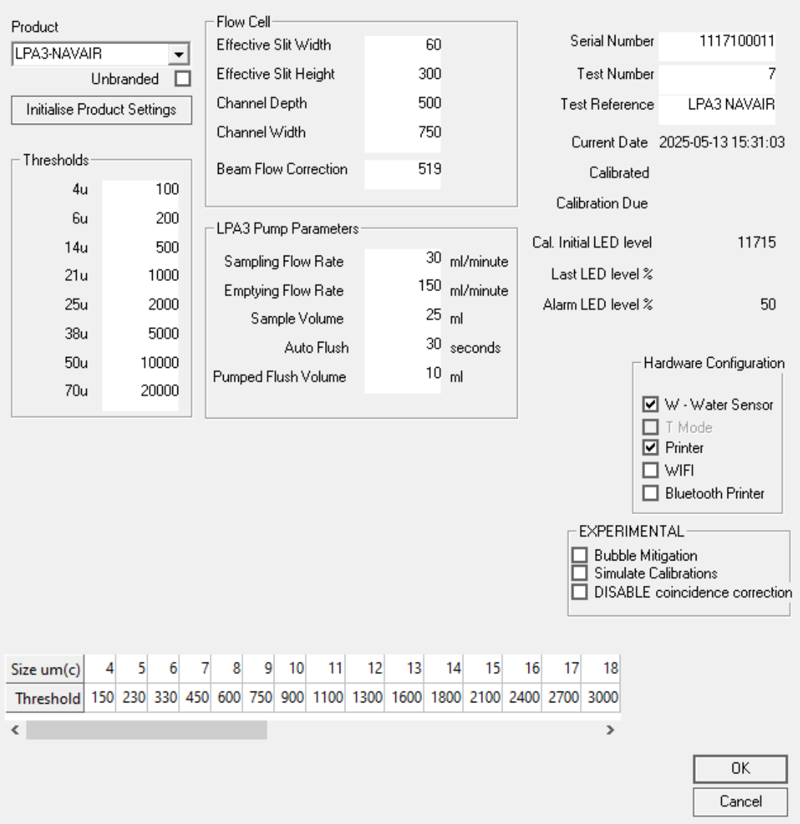
System Settings
- Change "Product" to LPA3-NAVAIR. Unit will reset.
- Initialise Product Settings
- Set serial number according to the one on the Block

Leave flushing with clean fluid for at least 20 minutes. Leave with fluid in unit for subsequent calibration.

Calibration
Setup
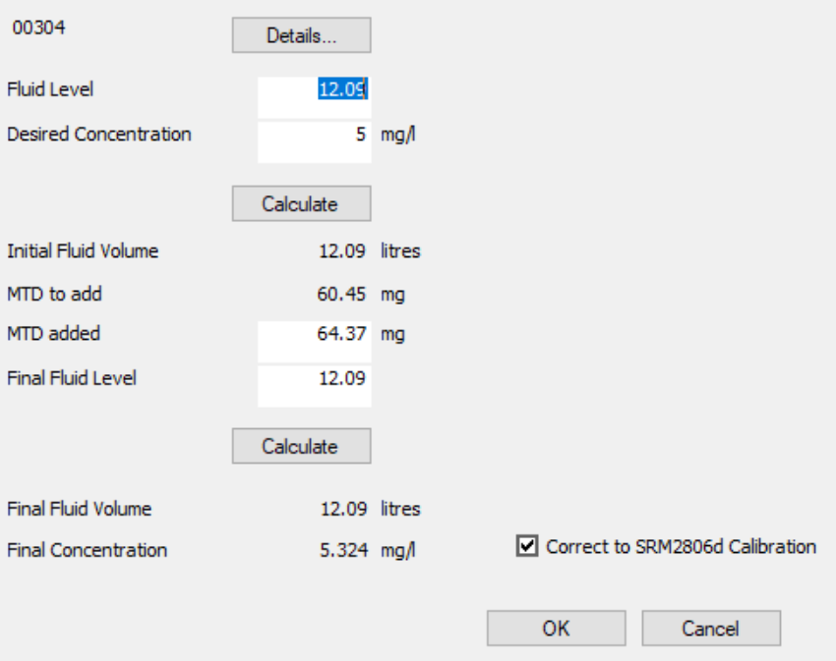
Use dialog to dose rig to 5mg/l MTD, "corrected" distribution tickbox on.
Distribution grid will populate and a line written to log indicating current target

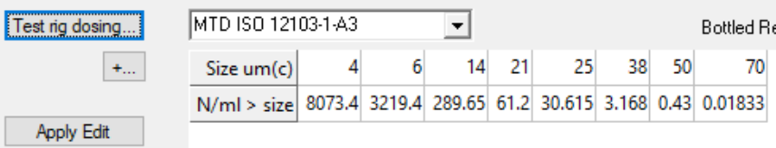

For Each Unit
Perform no-noise check a few times with clean fluid in block but test rig isolated (do this before calibration fluid through the unit.
Record Photocurrent and lowest noise value against serial number.
Connect to dosed test rig
Flush 100ml into waste
Flush for 1 minute
CAL START
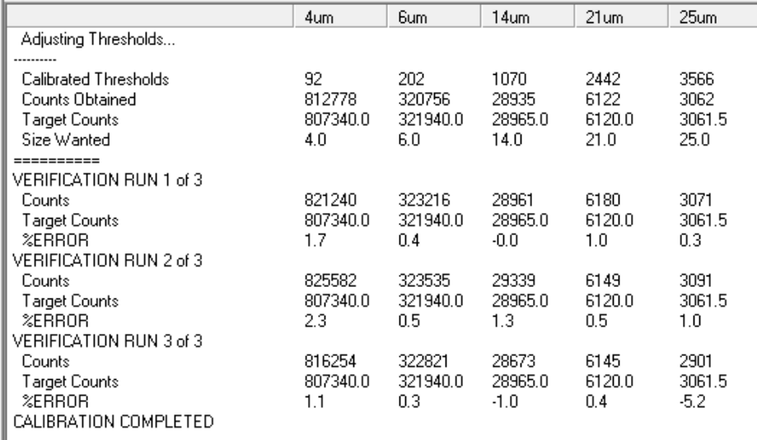
38+μm thresholds will not be reliable especially at 5mg/l
These need to be manually loaded from reference values.
As of 2025-05-13, thresholds for LPA3-NAVAIR are:
38μm | 9938
50μm(c) | 15300
70μm(c) | 25000

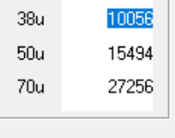
(CF automatically calibrated values)

2025-12-08 Snagging List

NAVAIR interface pins short circuit
1x didn't enumerate properly USB
PCB grounding check

